**Bypassing Firewall using VPN**

**Karan Amrutesh**

**Setup:** We use a host-only network adapter in our VMs so that we can emulate internet that connects the two VMs:

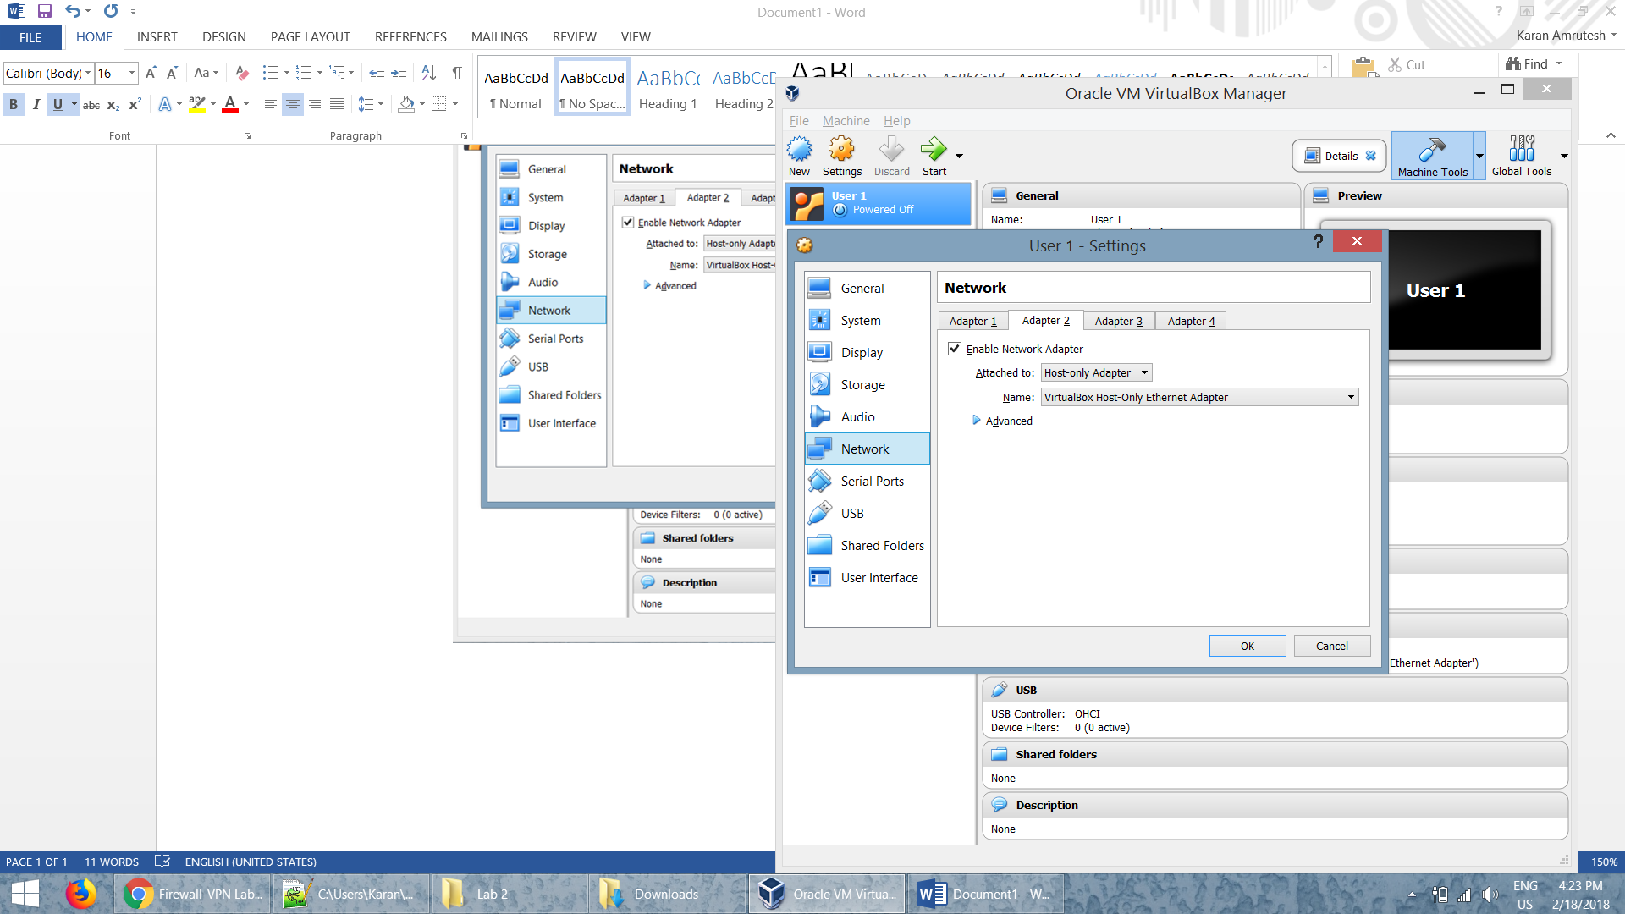

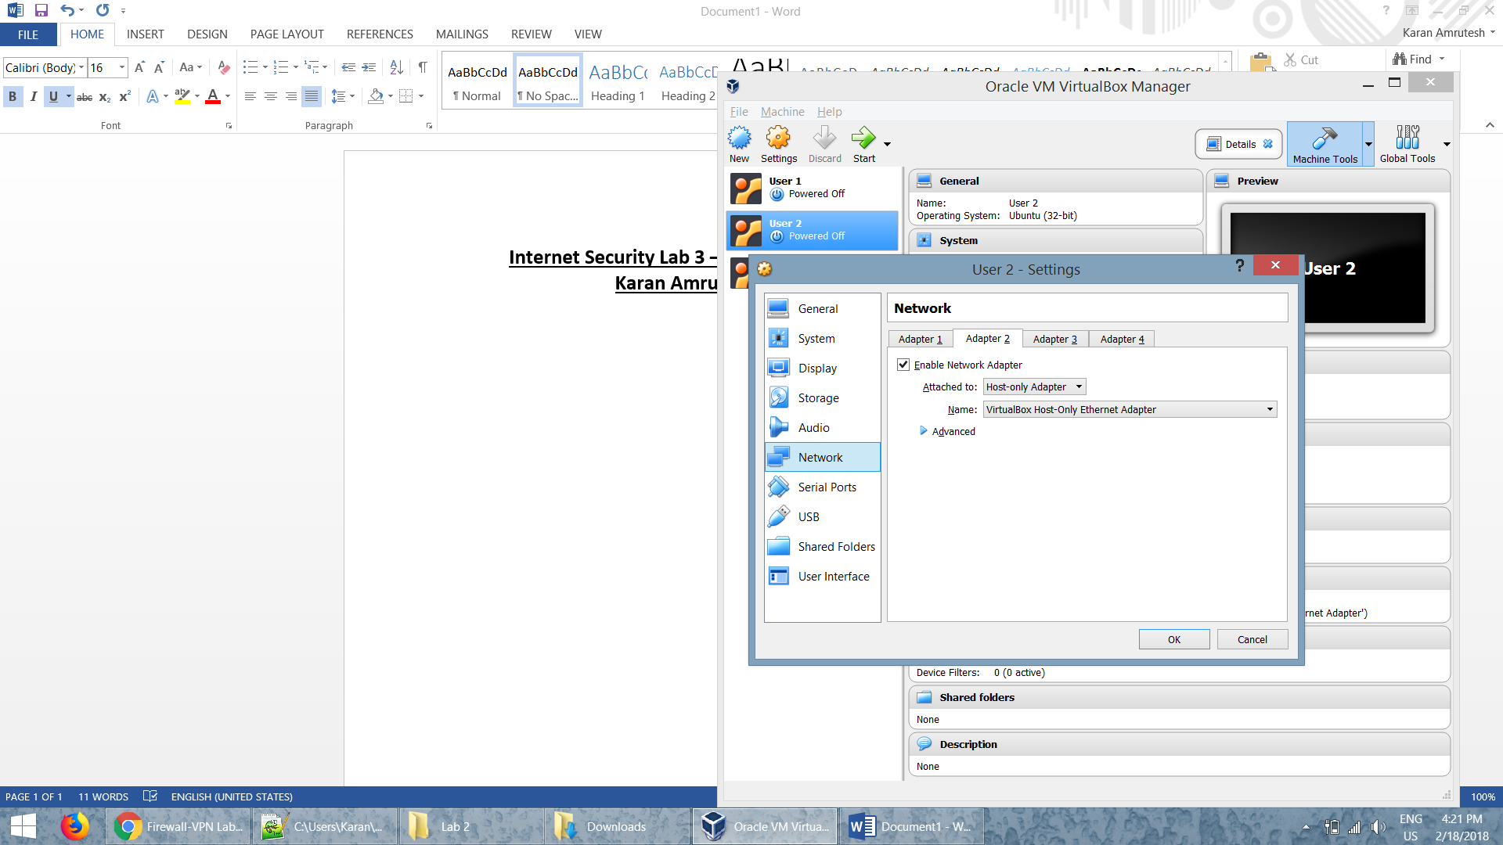

**Task 1: Create a Host-to-Host Tunnel using TUN/TAP**

* We execute the tunserver program on the server side of the tunnel. As seen in the above screenshot tun0 virtual network interface is created.

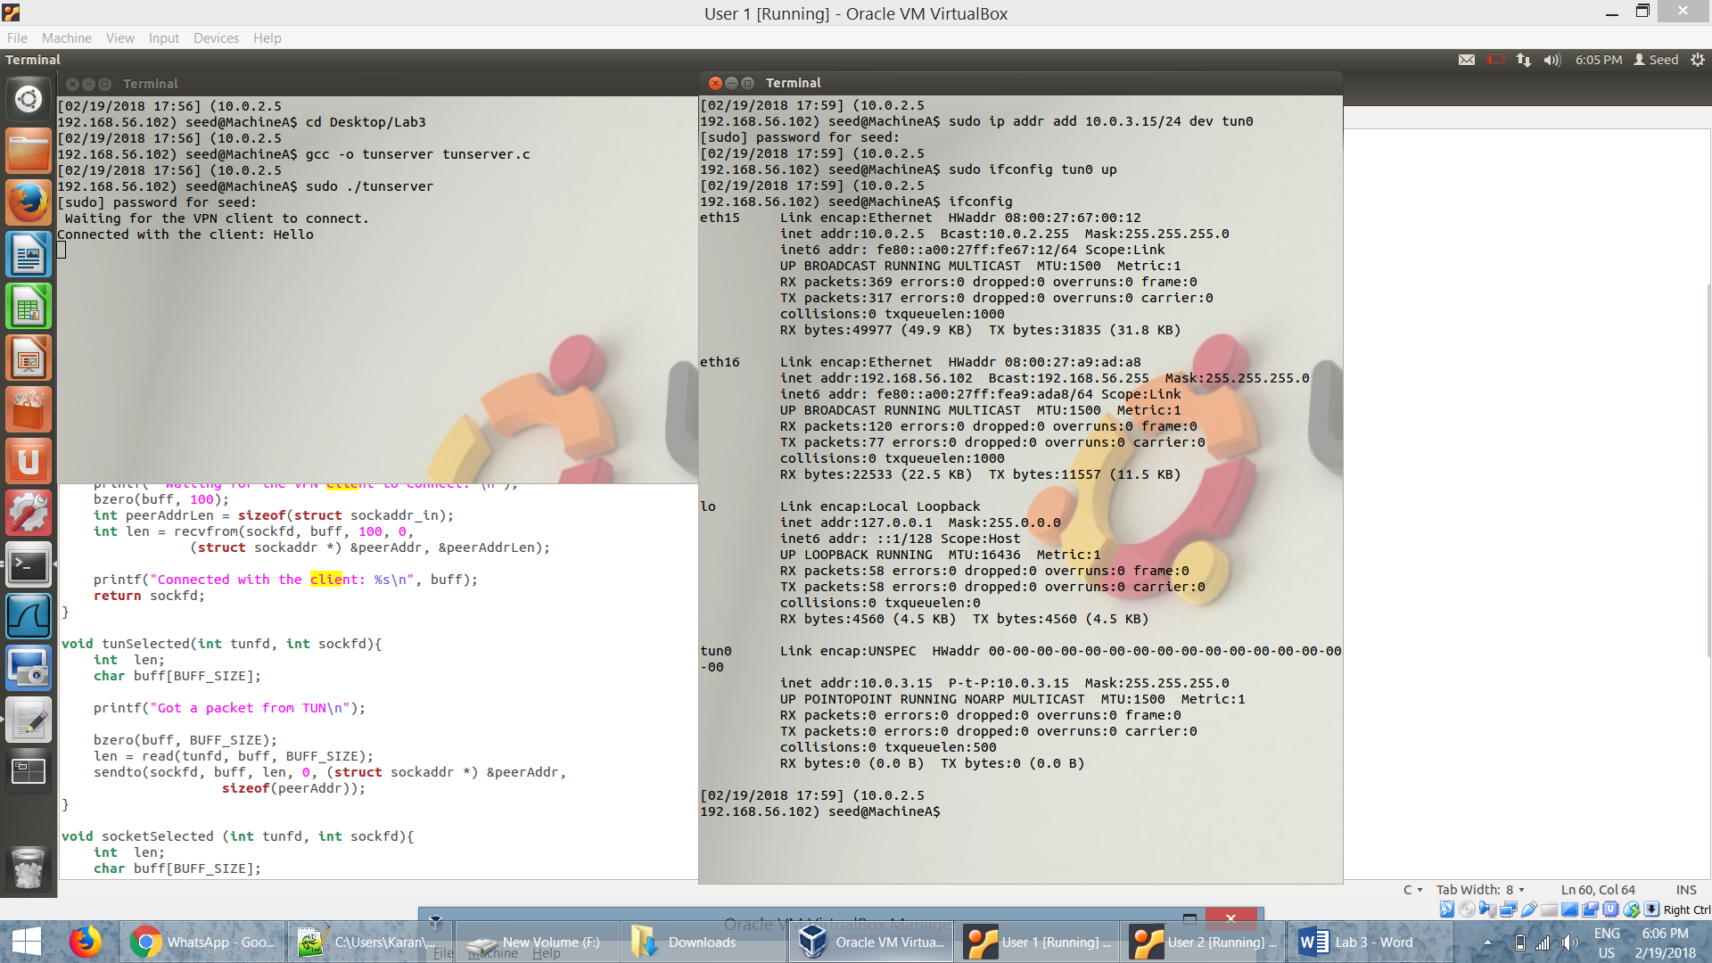



* Here tun0 is created and it is on the server side of the tunnel. After that we have to assign an IP address (10.0.3.15) to the interface and then we have to bring up the interface.
* We execute the tunclient program on the client side of the tunnel. As seen in the below screenshot tun0 virtual network interface is created on the client side.

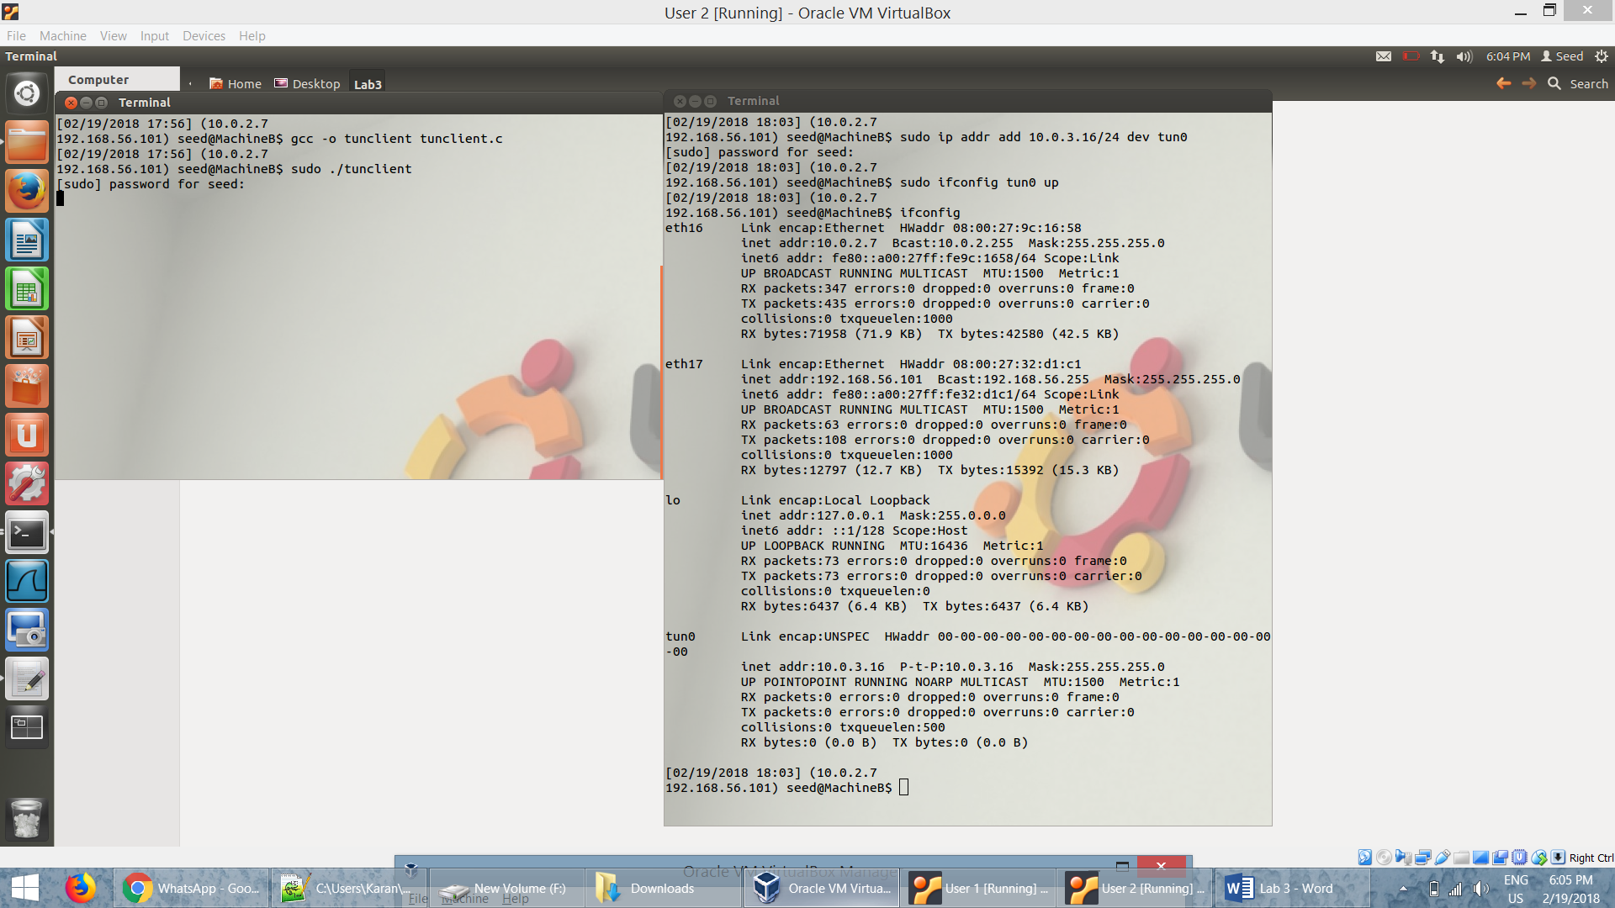



* Here tun0 is created and it is on the client side of the tunnel. After that we have to assign an IP address (10.0.3.16) to the interface and then we have to bring up the interface.
* We add a routing path in both side of the tunnel, server and the client, so that traffic can go through the tunnel and it directs all the packets for the 10.0.3.0/24 network through the interface tun0, from where the packet will be hauled through the tunnel.
* The screenshot shows that the route is added in the routing table.

Server Side:

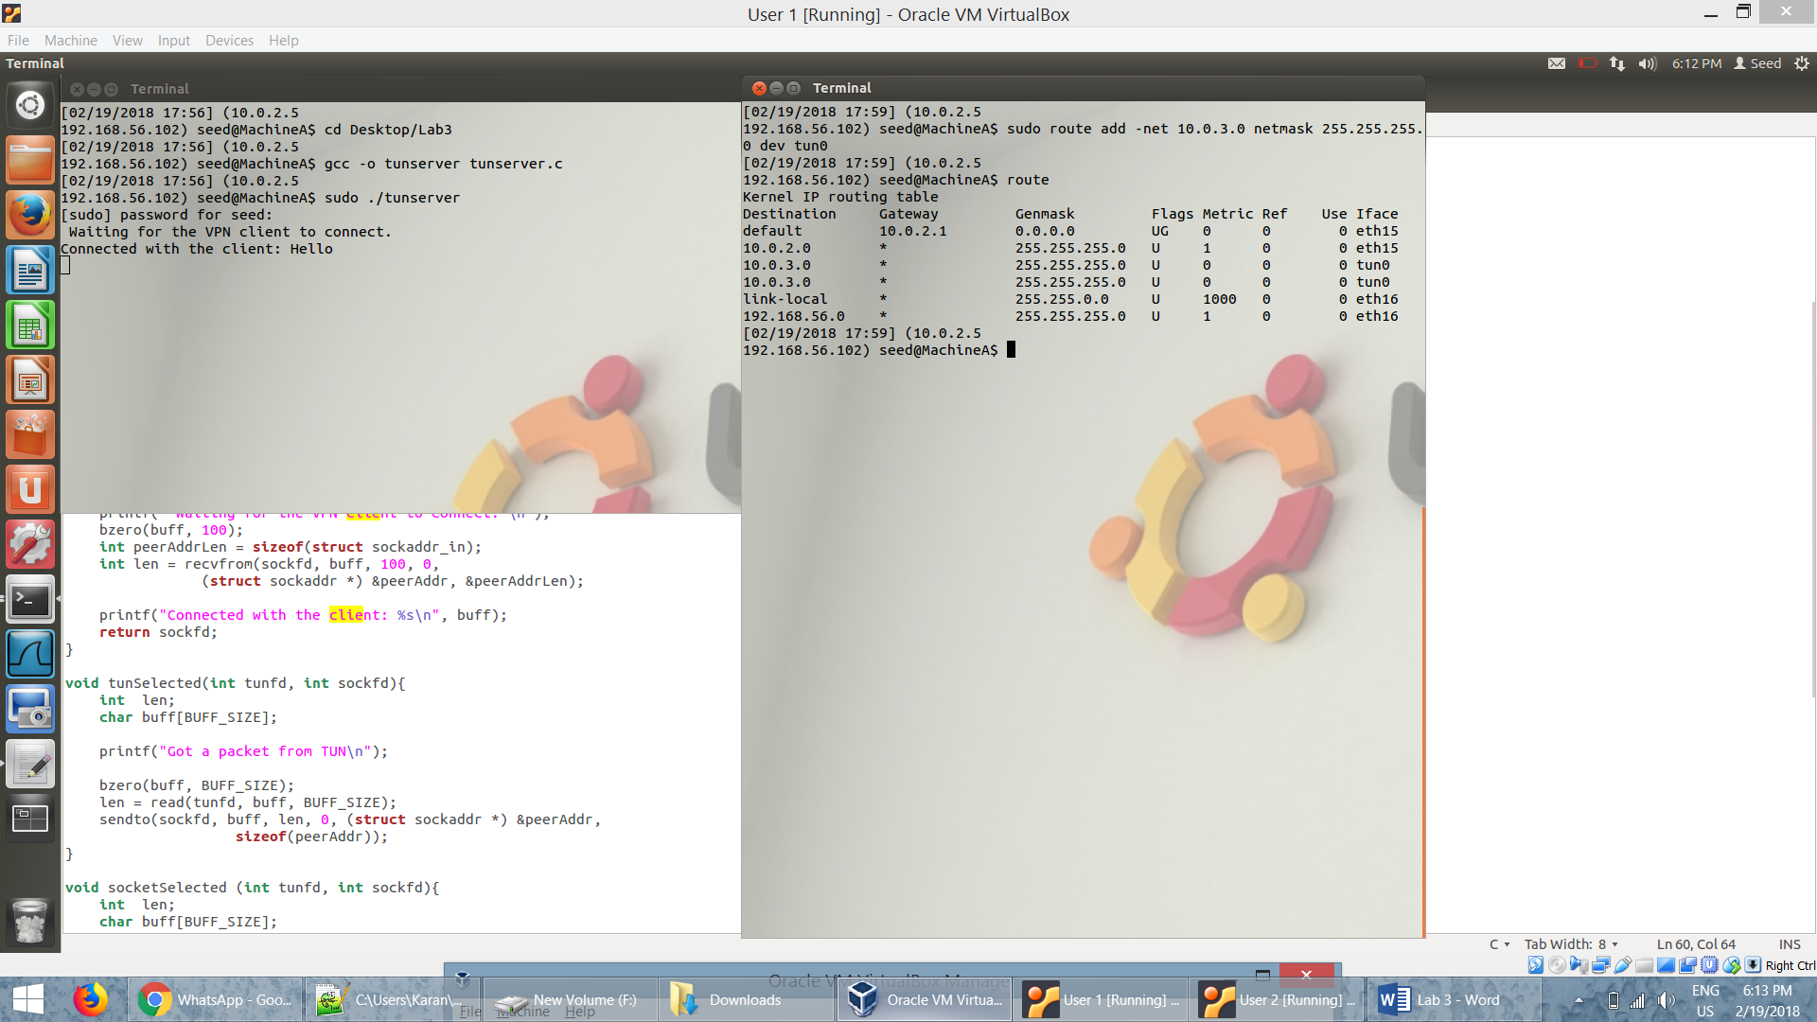

Client Side:

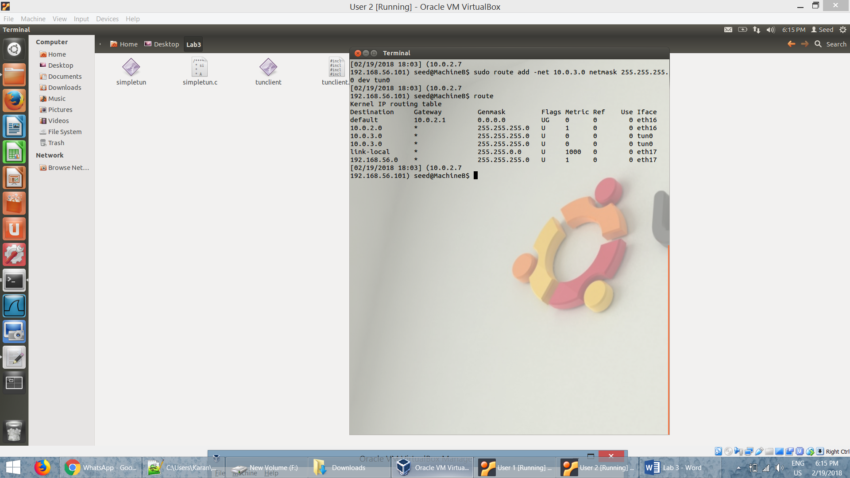

* After establishing the tunnel, we can access the client (*10.0.3.16 or* 192.168.57.101) from the server side (*10.0.3.15 or 192.168.56.102*). We test using ping and establish a ssh connection.

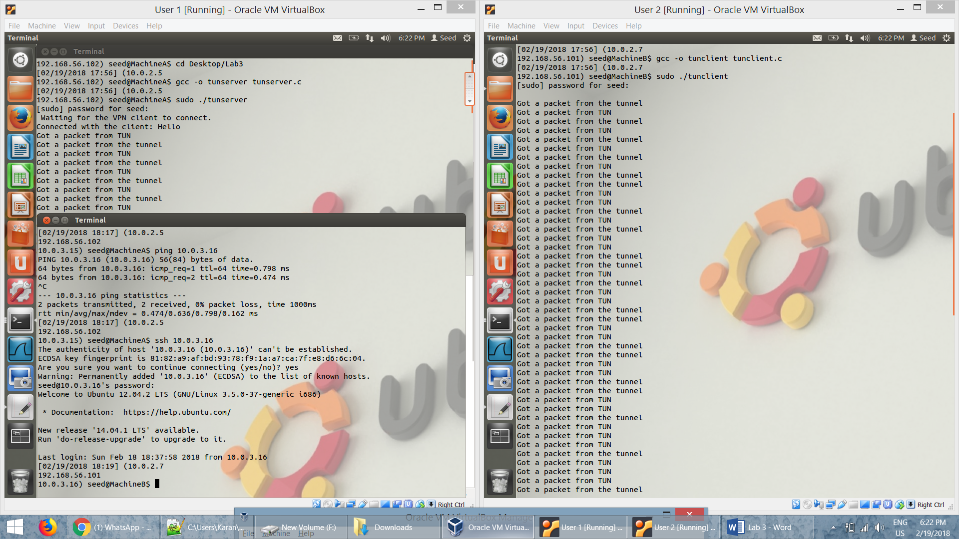

* From the screenshot, we can see that the packets are received and sent from the server as well as the client through the tunnel.
* Similarly, after establishing the tunnel we can access the server *(10.0.3.15 or* 192.168.57.105*)* from the client *(10.0.3.16 or* 192.168.57.101). We then test using ping and establish a ssh connection through the tunnel

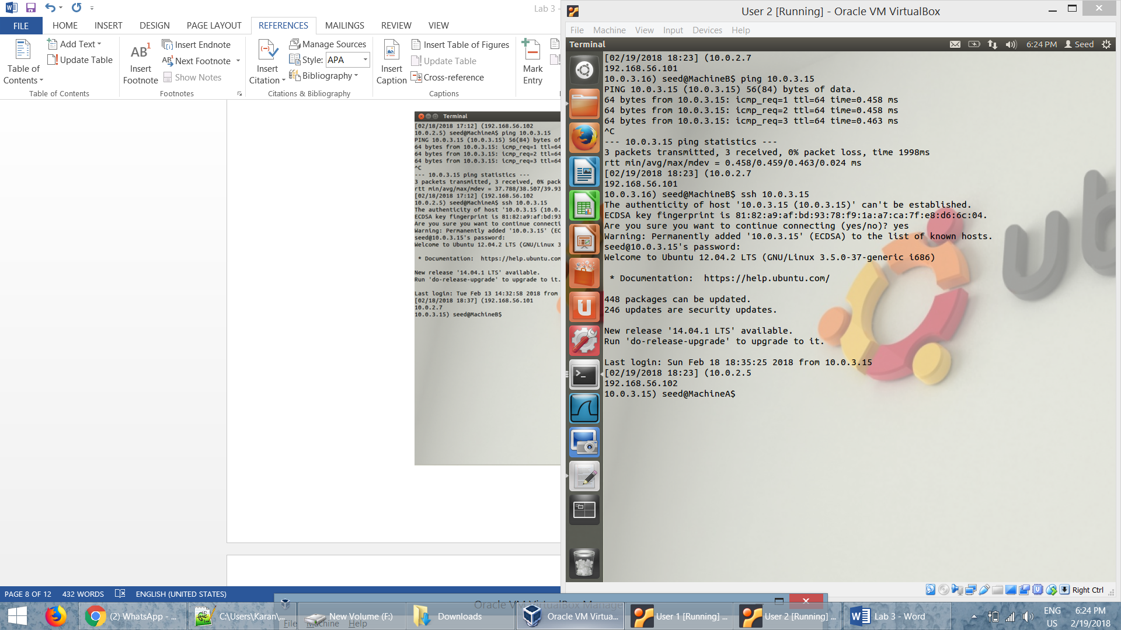

* We can see that the ping is successful and an ssh is established to the client through the tunnel.

***Task 2: Set up Host-to-Gateway Tunnel***

* The commands in the screenshot below sets up ip forwarding and then clears the iptables rules and then adds a rule on postrouting position to the natnetwork adapter connected to the VPN server.

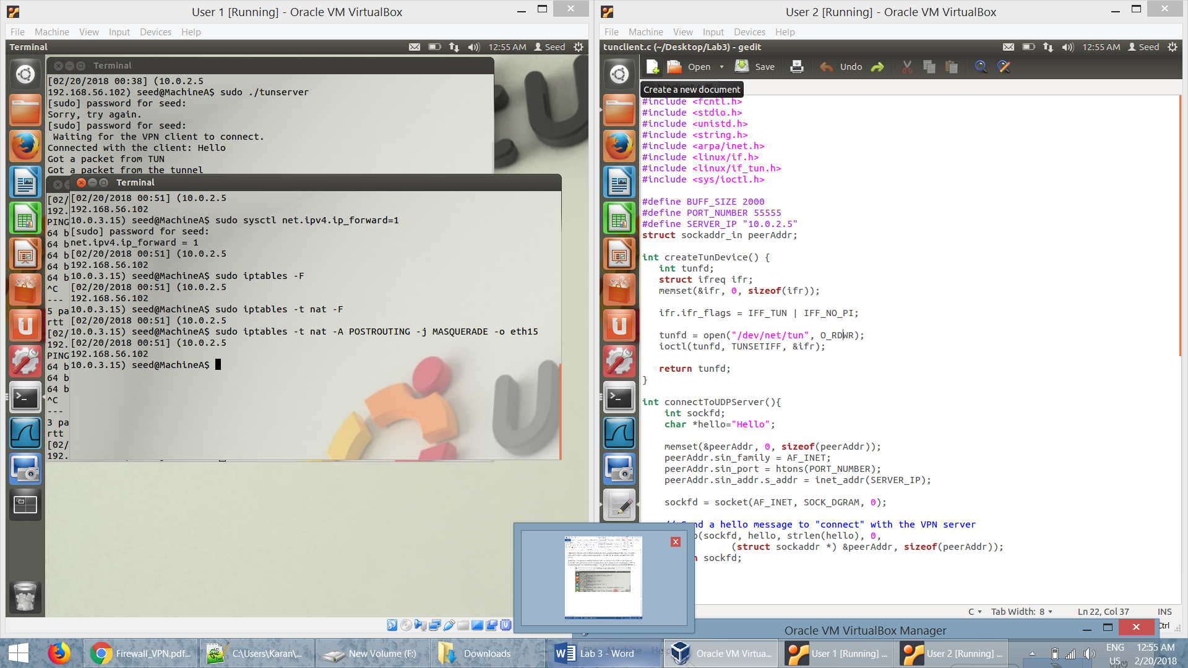

* The packets received at the server end is not meant to stay at the server, it must be forwarded. This is why we set up ip forwarding. After that we have go around the limitation of NAT by adding a new rule in the postrouting position to the nat network adapter connected to the VPN server.

***Task 3: Set up Firewall***

* We set up a firewall in the client machine to block all packets to news9.com (*64.14.56.100*).

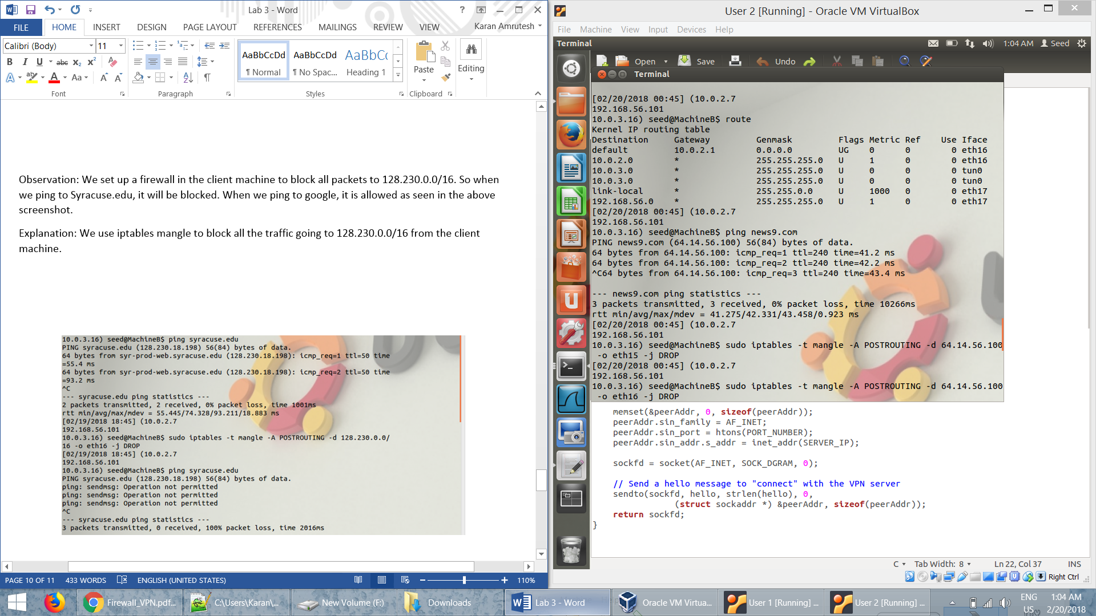

* We use iptables mangle to block all the traffic going to (*64.14.56.100*) from the client machine.

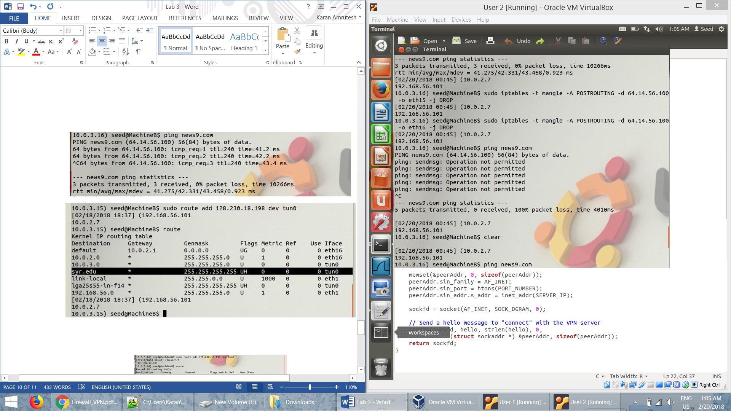

* Then we add the IP address of news9.com to the routing table so that we route it through the tunnel.

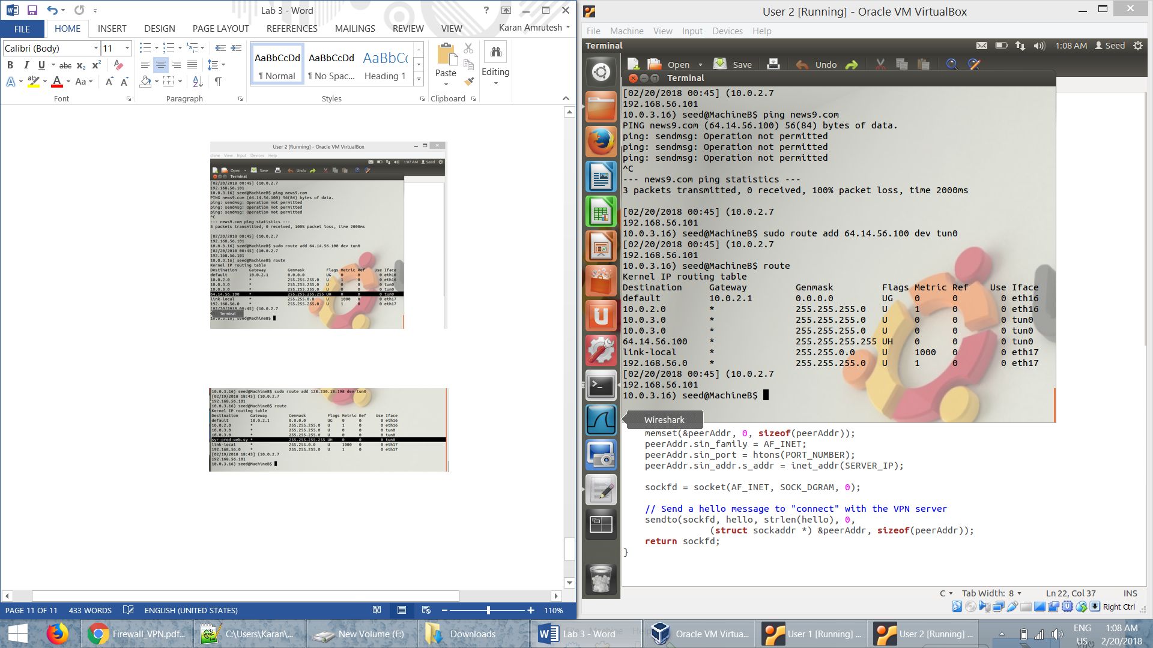

***Using telnet in our VPN:***

* We create a ufw rule to block telnet from 10.0.2.7 to 10.0.2.5. We then add a route so that all packets go through the tun0 interface when they have to establish a telnet between the systems. The telnet is successful and we get a reply. The wireshark capture is evidence of this.

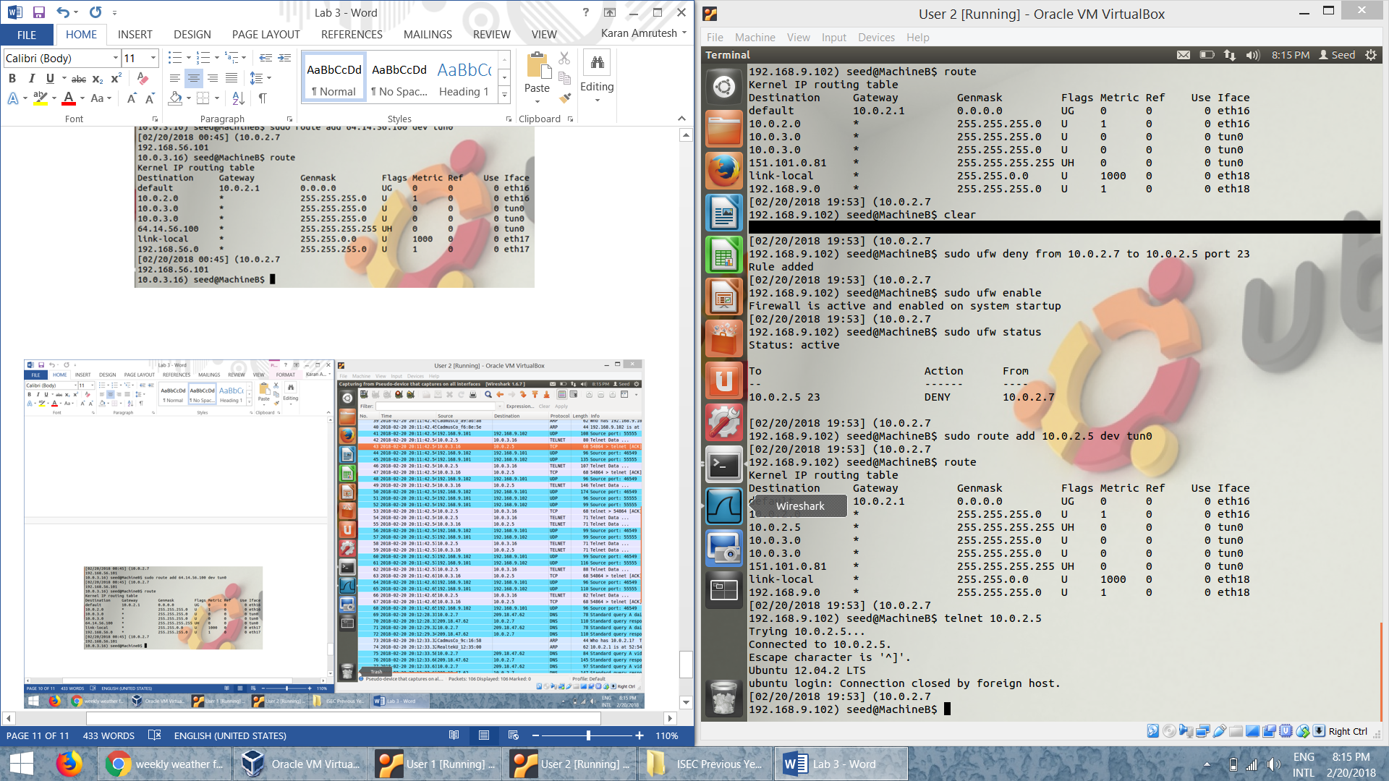

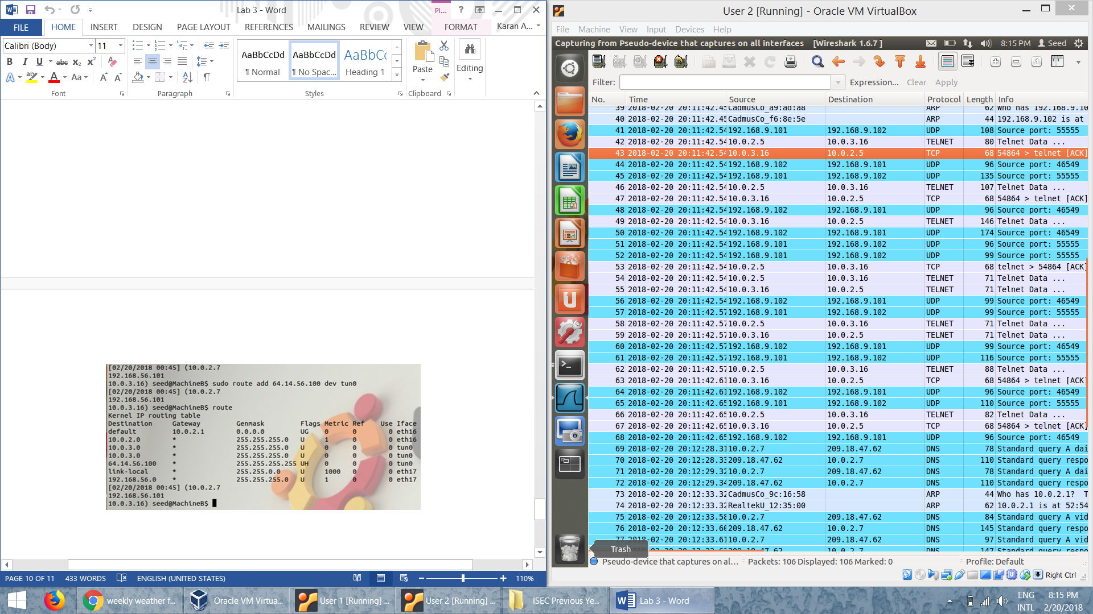

* The packets to 10.0.2.5 will go through the tun0 interface to the client side of the tunnel. The packets are then sent to the destination from the VPN server.